Git ve Github usage

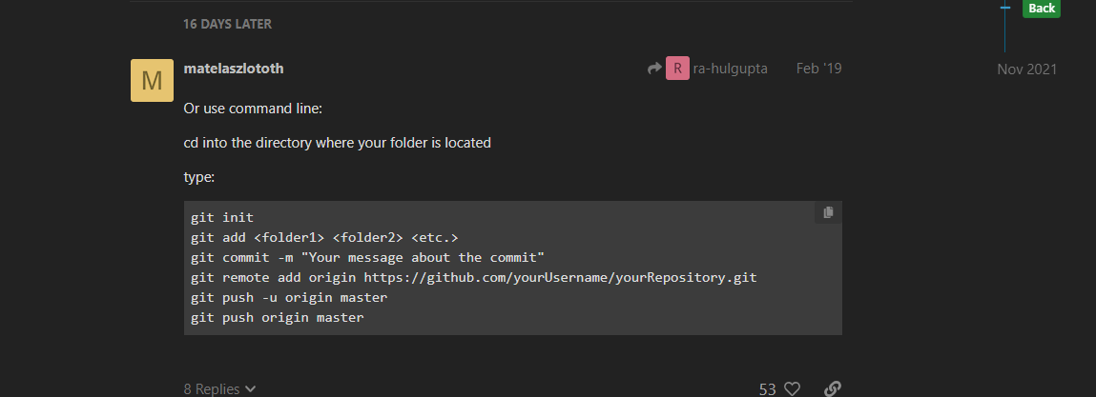

git init

git add <folder1> <folder2> <etc.>

git commit -m "Your message about the commit"

git remote add origin https://github.com/yourUsername/yourRepository.git

git push -u origin master

git push origin master

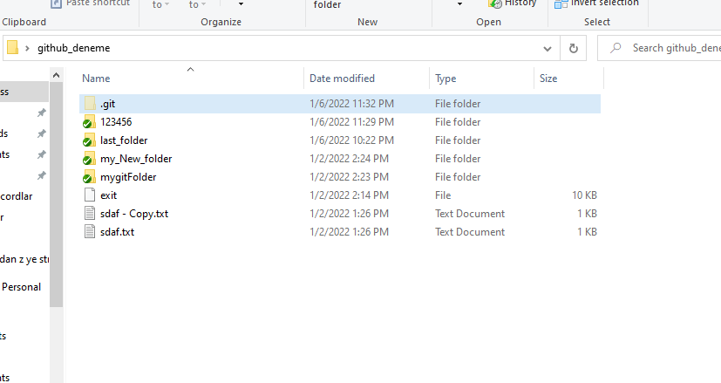

.git uzantılı file I silersen yeniden git init yapsan bile hata veriyor

You have to create new repository for this circumcitances

If you see this error this errror tells you alreaddy define a renote origin



So you have to remove this defined origin



After above command you can continue normal commands

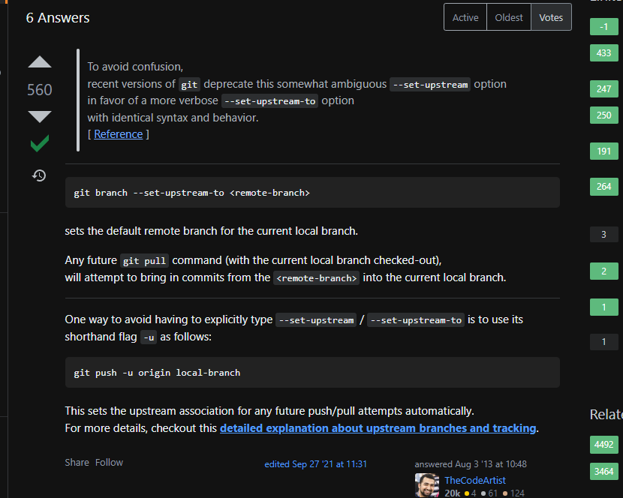

If you see



This error you can change -u by -f

git push -f origin master

if you don’t want to all file or folders you can create gitignore extension folder

attention:folder heve not a extension so ,f ypu want to add any folder to this text you can write just folder

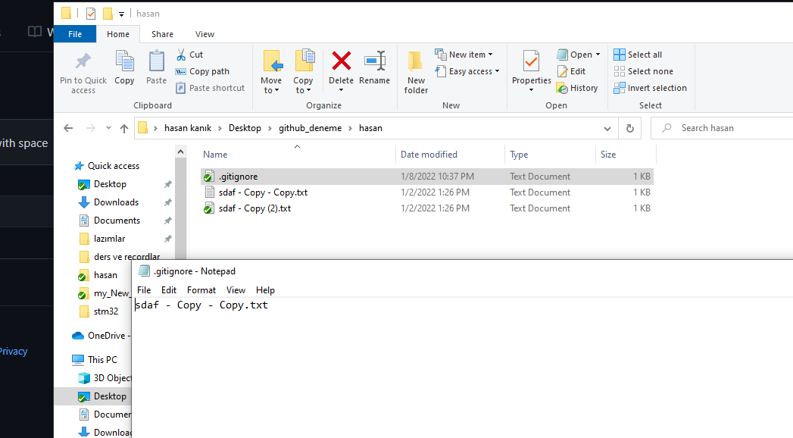

If you want to update your changed data

